## 10.Central Cinema *

Use the given skeleton to solve this problem.

**Note:** You have NO permission to change directly the given HTML *(index.html file)*.

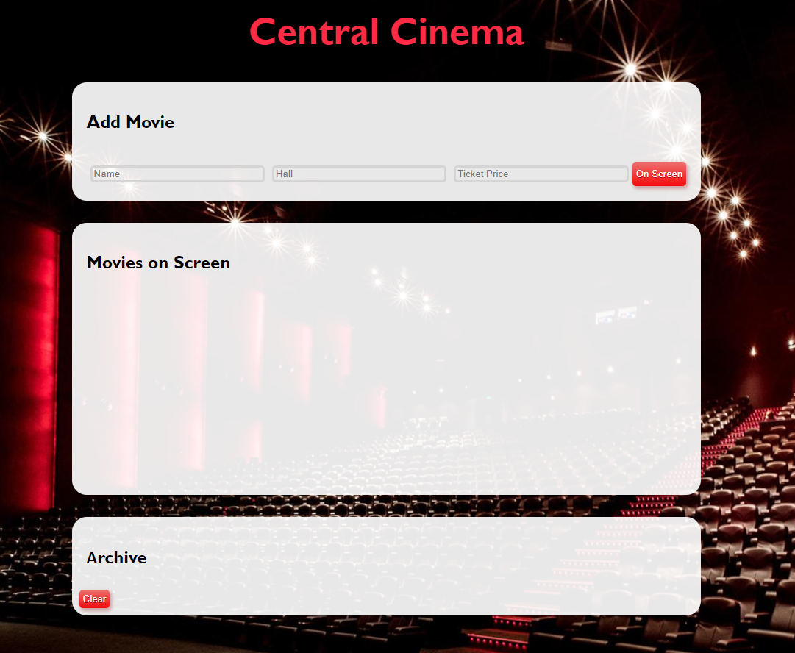

### Your Task

Write the missing JavaScript code to make the Central Cinema application work as expected.

Each movie has a **Name**, **Hall** and **Ticket** **Price**.

When you click the **[On Screen]** button and **only** if **inputs** are all **filled** and the ticket **price value** is a **number**, then a new **list item** should be added to the **Movies on Screen** section. Clear the inputs.

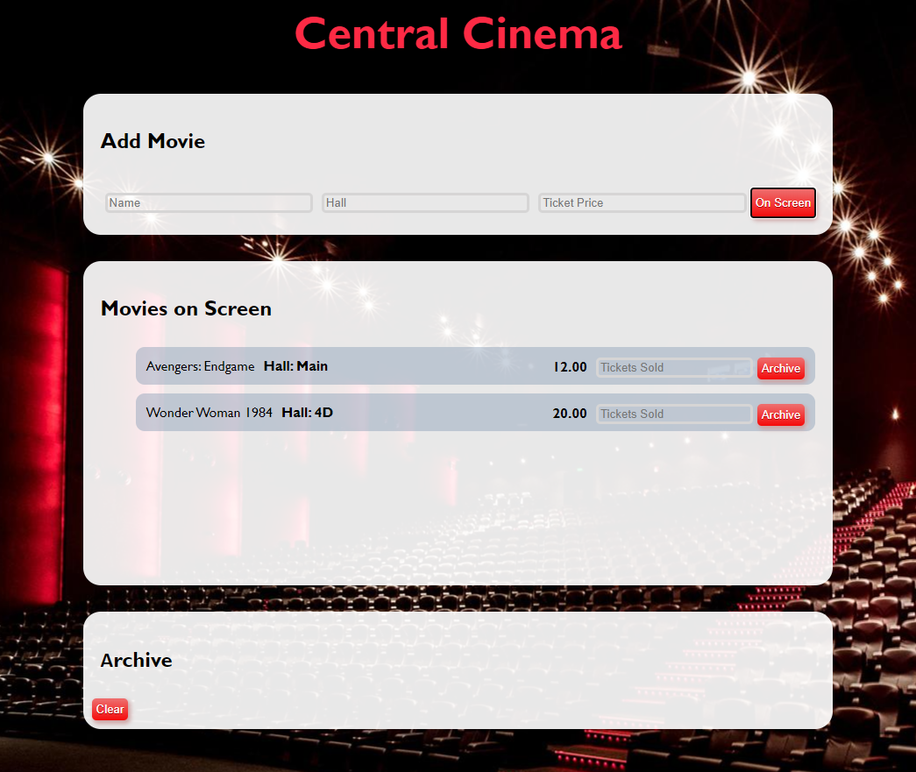

The new item should have the **following structure**:

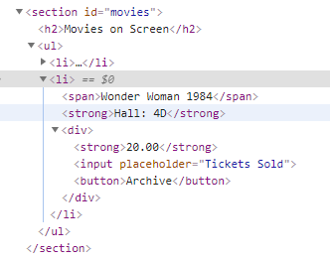

You should create a **li** element that contains a **span** element with the name of the movie, a **strong** element with the name of the hall like: **`Hall: ${hallName}`**, and a **div** element. Inside the **div** element, there is a **strong** element with the ticket price **(fixed to the second digit** after the decimal point), an **input** element with a **placeholder** containing:"**Tickets Sold**" and a button **[Archive]**.

When you click the **[Archive]** button and **only** if the input for tickets count is **filled with a number** like:

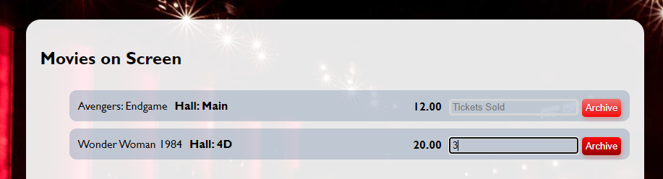

You should **add** that item to the **Archive** section like a list item in the **ul,** calculating the total profit of the movie like this:

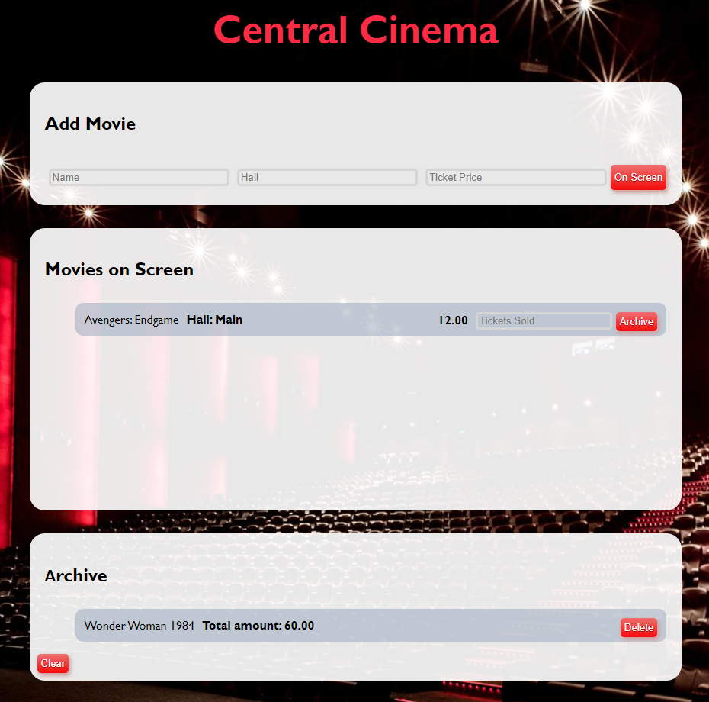

Use the following format:

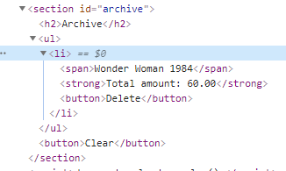

Here we have a **list item** containing **span** element with the name of the movie, **strong** element with total profit like: **`Total amount: ${total price}`**, **fixed to the second digit** after the decimal point. Add a delete button **[Delete]**.

When you click the **[Delete]** button, you should **delete the current list item.**

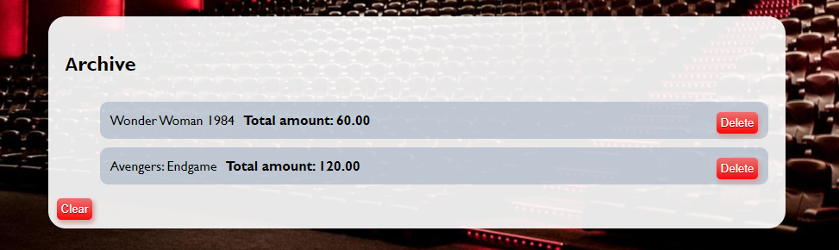

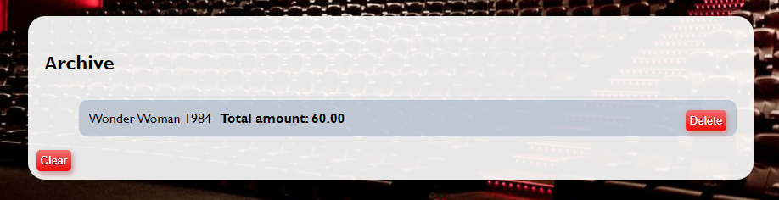

Finally, when we click the **[Clear]** button **delete** all **li** elements from the **archive** section. No matter how many archived movies we have the archive section leaves like this:

